GRID

1. Basic grid. The below column will be responsive no matter what. We can all more columns and the responsiveness is still there.

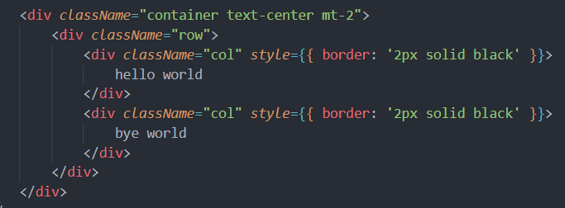

1. Different width grid

